**Color evolution through history**

*How has the use of colors in artwork evolved over time?*

A representation of the average colors used in each decade.

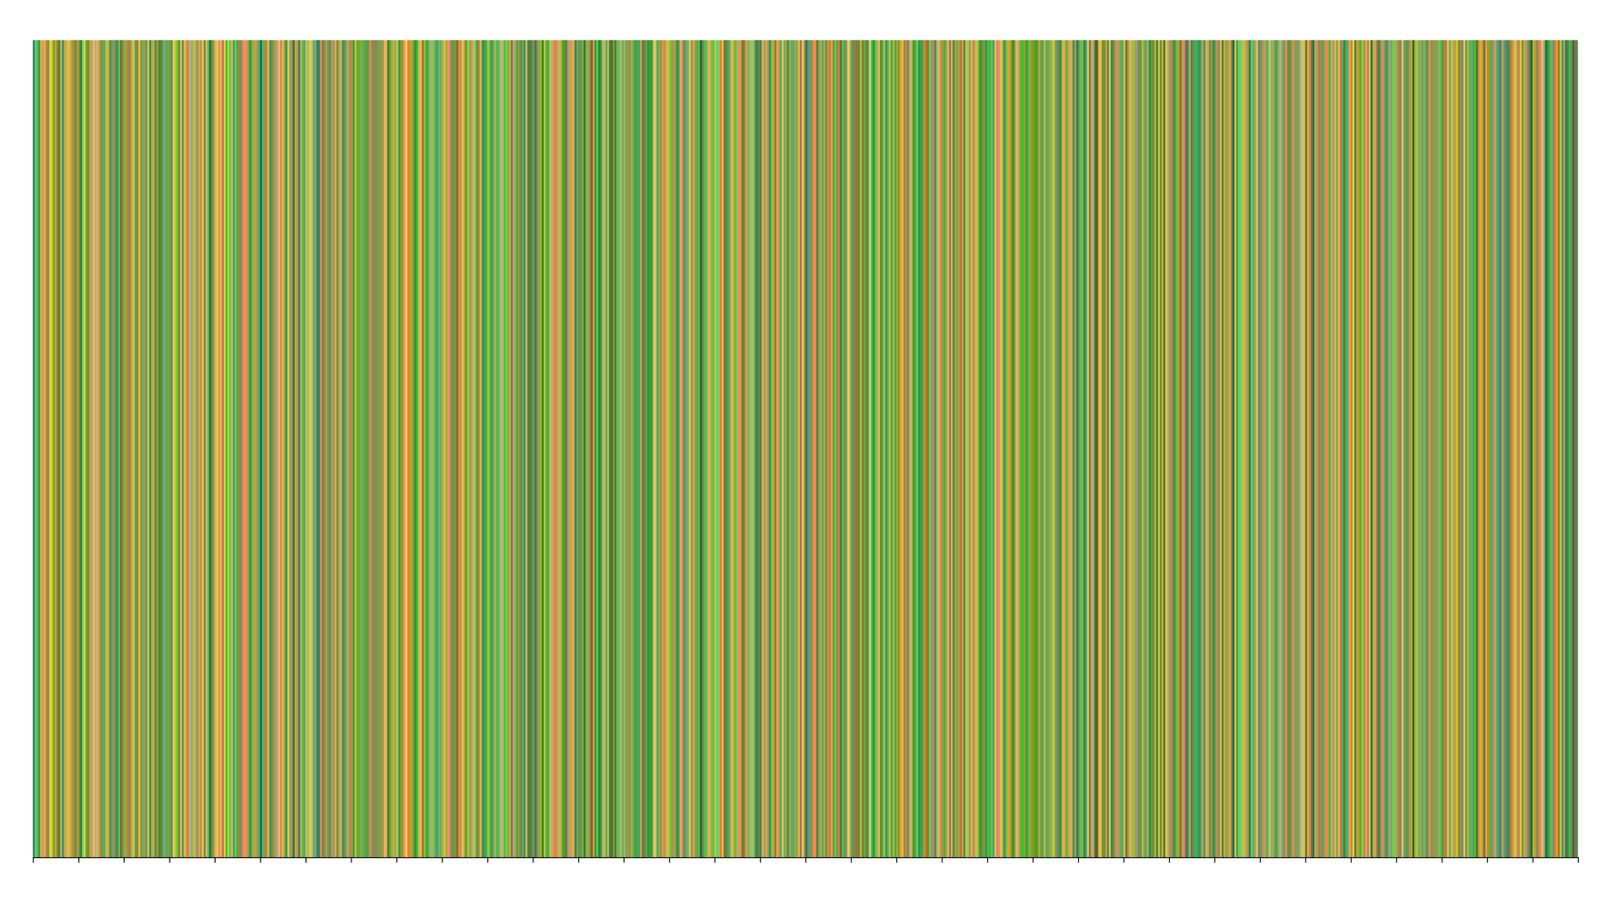

**Considerations**

* What should the timeline be? (all of the MET history, one particular time period?)
* Should it focus on all departments or just one? Maybe just one artist?
* Should height mean anything? If the X axis was decade, would splitting each line into years help?
* Would a small multiplies approach be better breaking down the collection into different areas of the world?

**A story of the MET collection**

*How are the artworks of the MET collection connected through geographic location and time?*

A randomly generated story, linking artworks through tags, artist, the artist’s start and end dates (the years they were born and died), the artist’s birthplace and the year the art was created.

In **1915** **Pablo Picasso** created **‘Guitar and Clarinet on a Mantelpiece’**, the same year that **Philip Webb** died. **Philip Webb** was born in **Oxford, England** where in **1809 Thomas Rowlandson** created **the ‘View of Oxford Castle’** which features **dogs & birds**. **Dogs and birds** are also featured in **Pierre Charles Canot’s 1778 Etching & Engraving ‘Dogs and Still Life’**…

**Proof of concept**

Adjacency matrix designed created myself. Connector language would be generated using a bank of different manually written statements dependent on which elements are being linked. Possibility to implement Dijkstra theory to create a path from one artist to another.

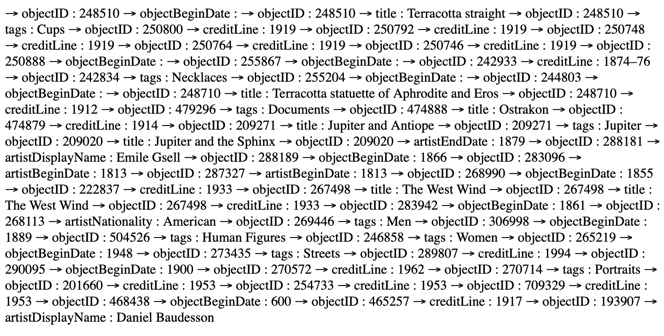

**Considerations**

* Which categories should the artwork be linked through? Some produce (like both artworks are ‘paintings’ produce too many results and it’s not interesting).
* Would it be more interesting to be able to select a start and end artwork for the story (or start and end artist)?
* Should it be limited only to a particular time period / type of art?
* Would it be more interesting to be involved in the creation of the next part of the story by selection ‘connectors’ such as ‘same year’ or same place’ etc.?

**Connected**

*What are the most popular topics in art? What topics appear in the same artwork together?*

A network visualization showing the topics that artists represent and when they are seen in the same art together.

**Implementation**

Implemented using <http://sigmajs.org> graph module. Size of node to represent how often the tag has been used, each edge would represent a connection of two tags being used in the same artwork.

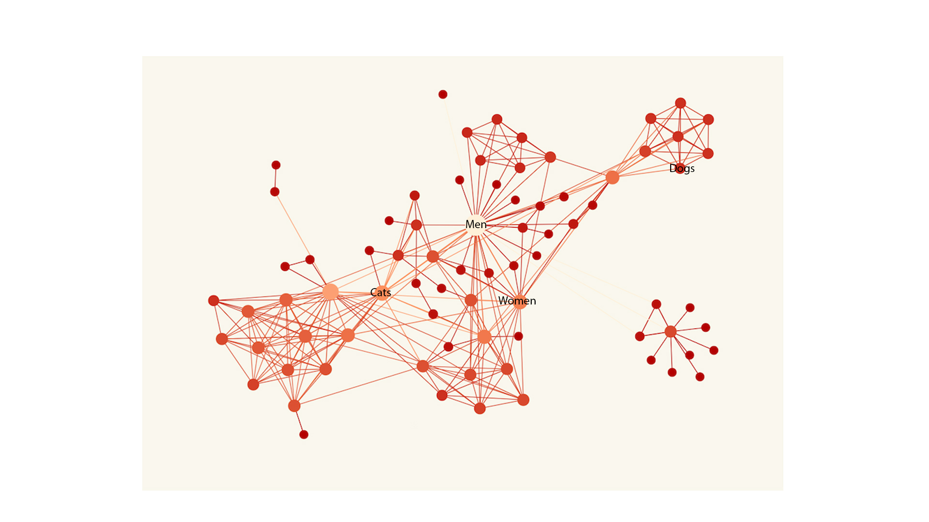

**Considerations**

* Should color represent something (department, medium etc.)?
* Would it be interesting to see if the tags changed over time?
* Would it be interesting to have dates as part of the tags?
* Should the number of tags be limited to limit the complexity of the image?
* Should the edge (line) thickness or color be used to show how often two tags are linked?
* If you could add a tool tip, what would it be?